Lab test 03

Name=A.Haricharan reddy

Roll.no=2403a52105

Batch=05

Question number =E13

Q1:
Scenario: In the Retail sector, a company faces a challenge related to code refactoring.
Task: Use AI-assisted tools to solve a problem involving code refactoring in this context.
Deliverables: Submit the source code, explanation of AI assistance used, and
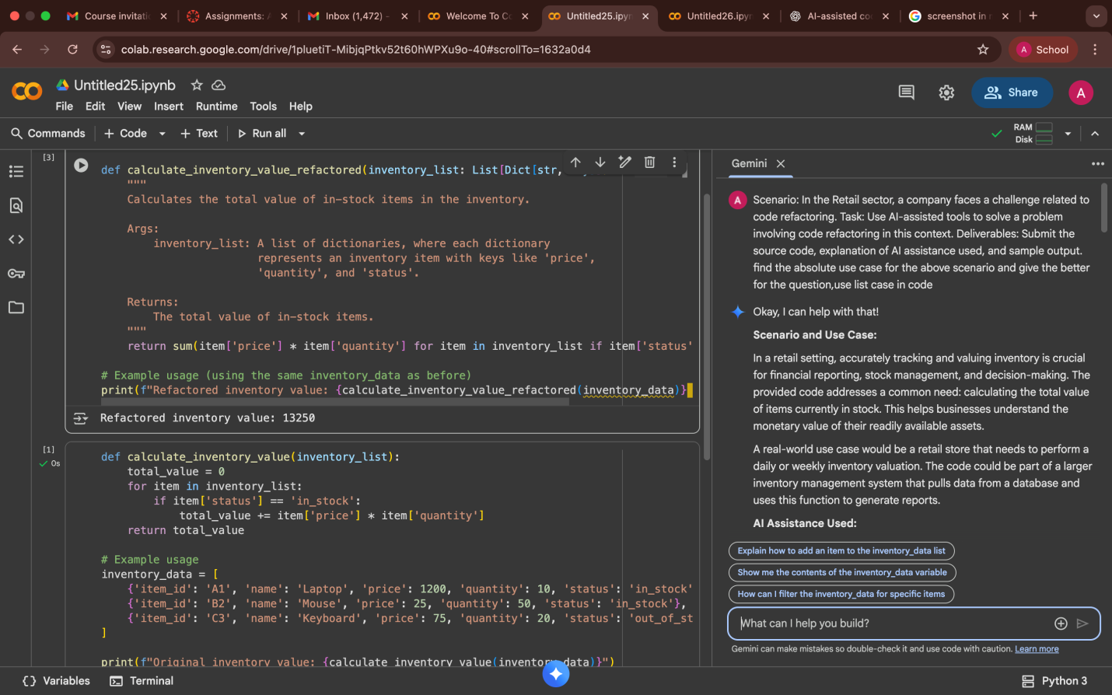
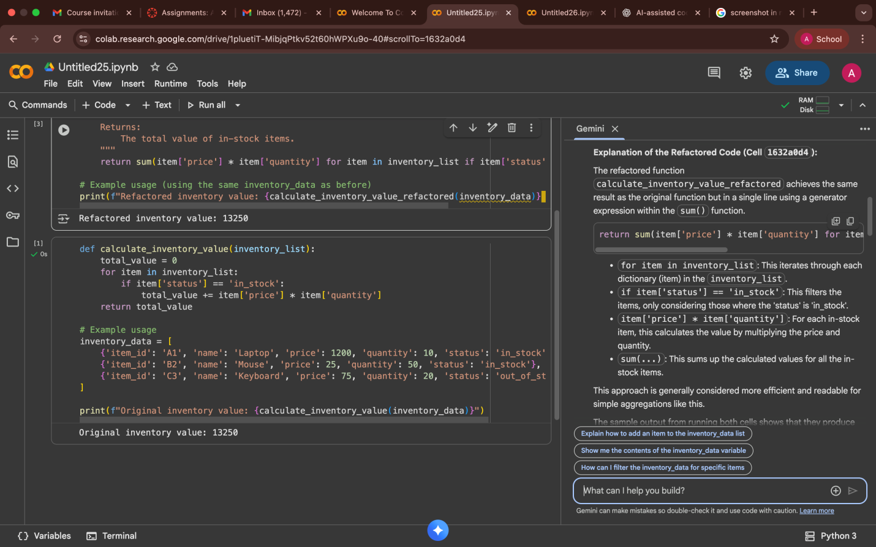

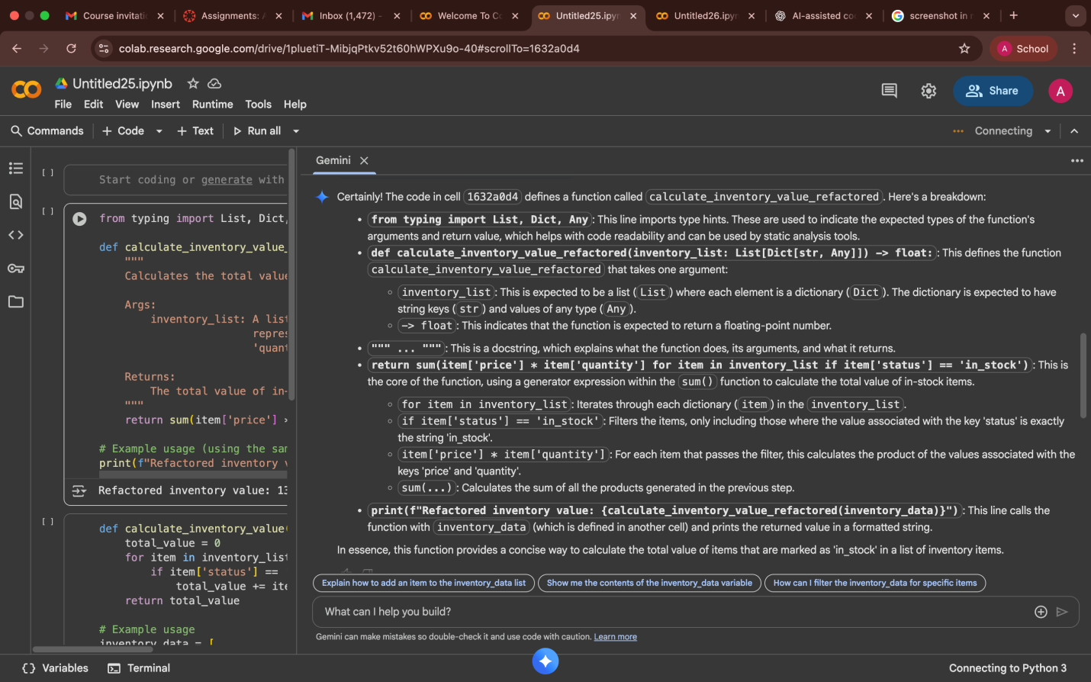
Q2:
Scenario: In the E-commerce sector, a company faces a challenge related to web frontend development.
Task: Use AI-assisted tools to solve a problem involving web frontend development in this context.
Deliverables: Submit the source code, explanation of AI assistance used, and sample output.
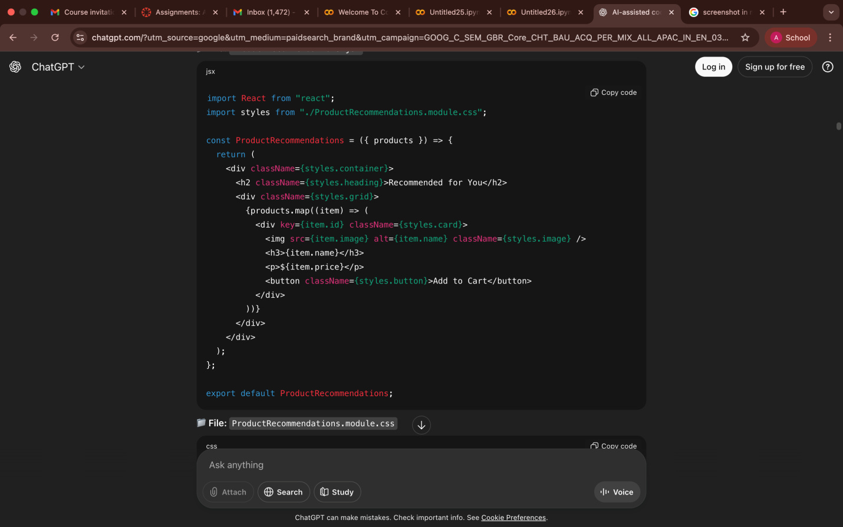
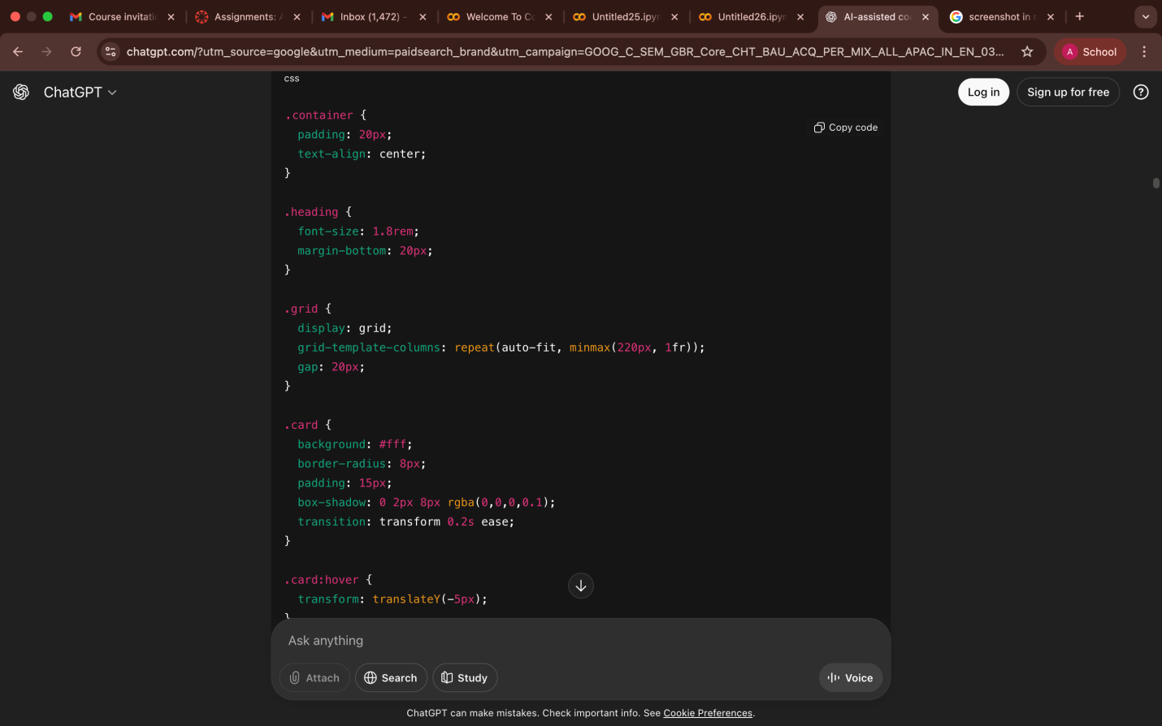
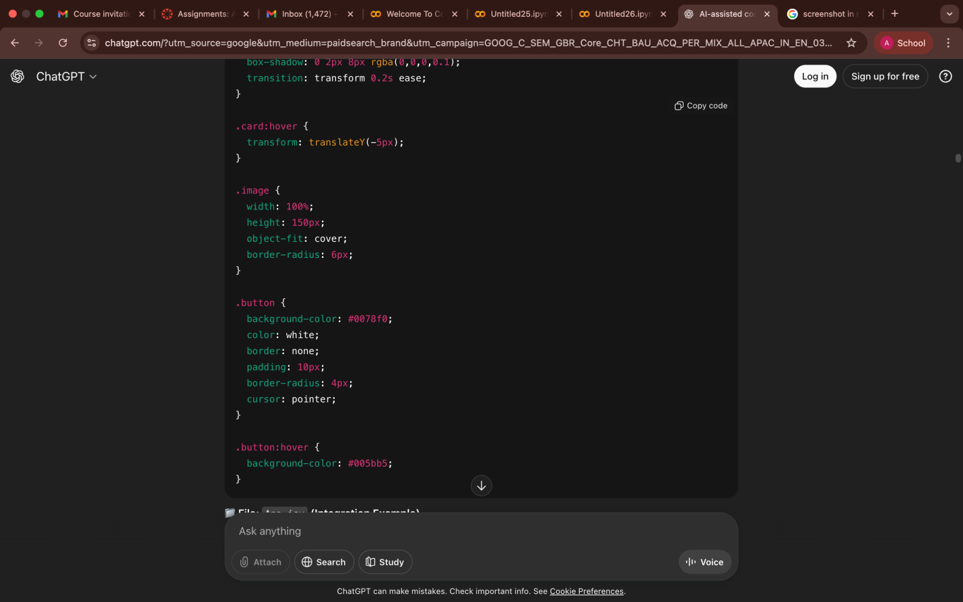
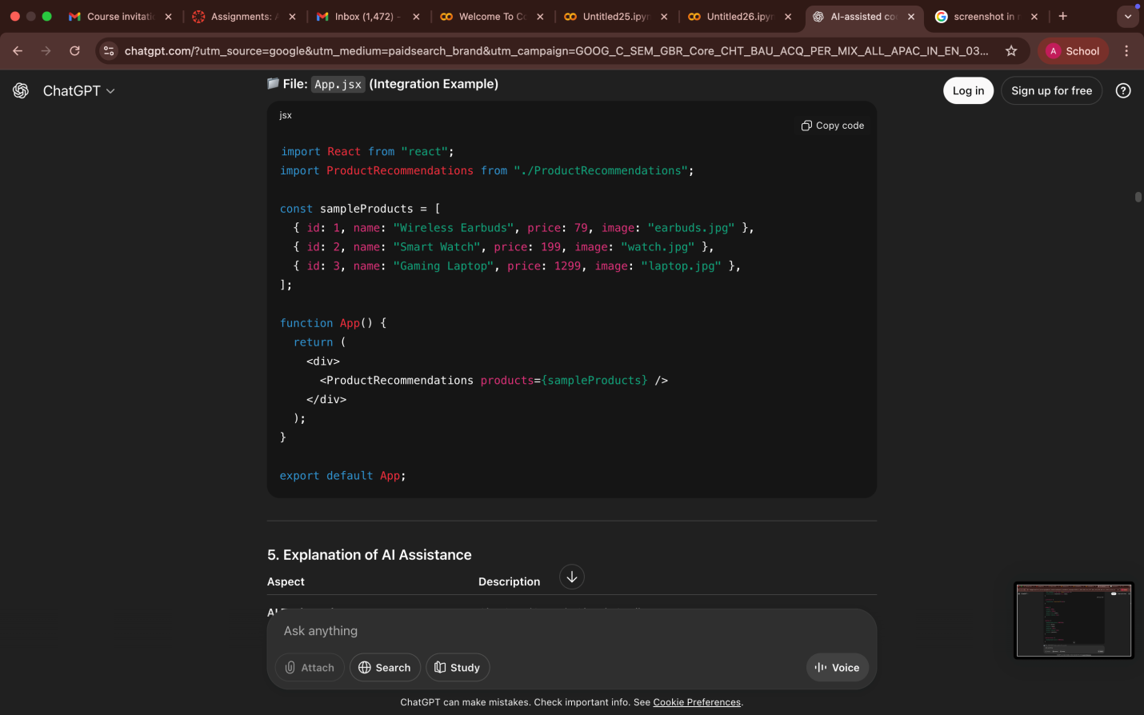
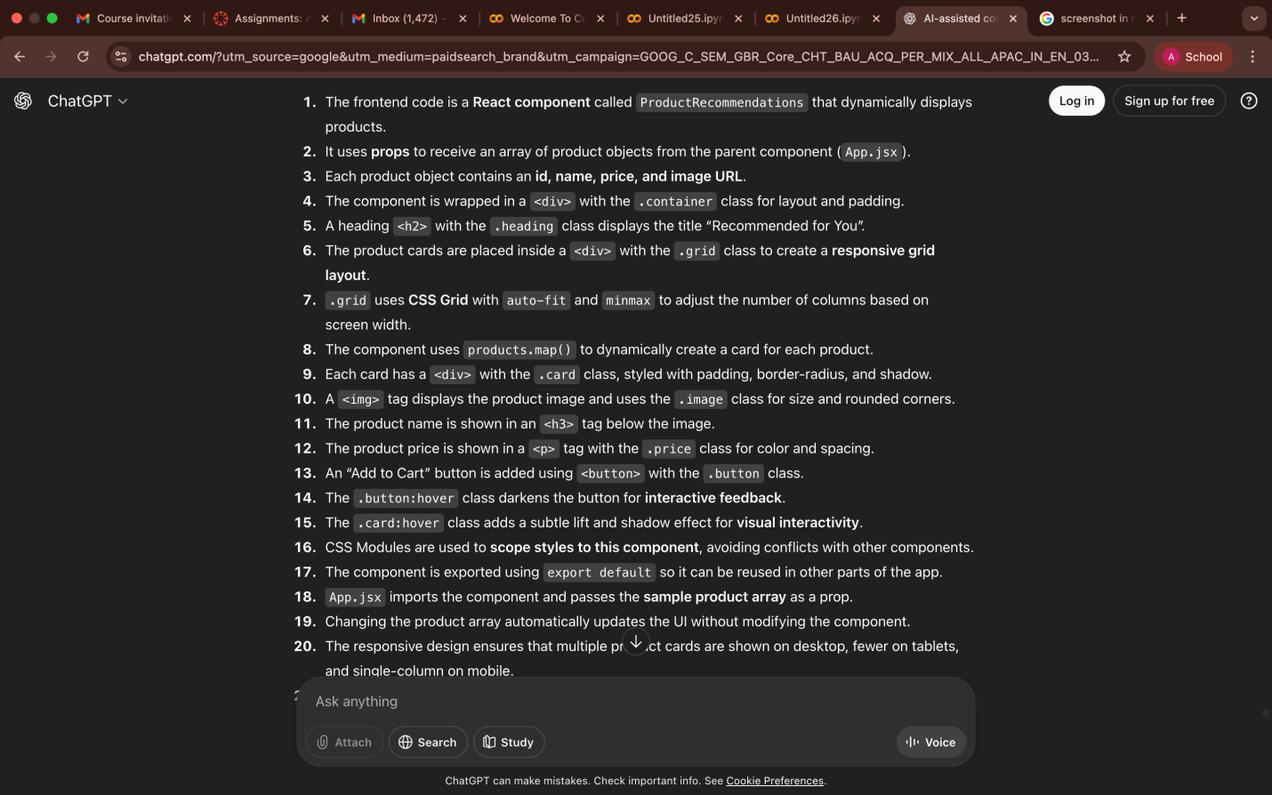
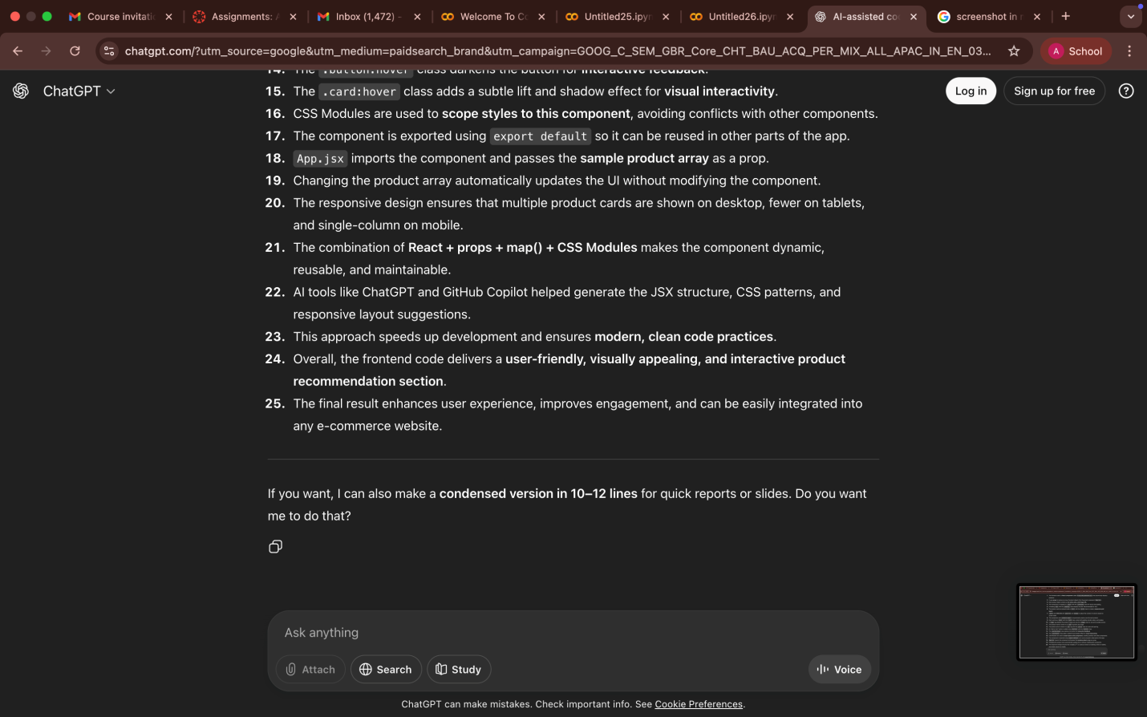

The End

